G51WPS Website Report

<http://avon.cs.nott.ac.uk/~axm13u/wps/website.html>

I used HTML to essentially create the backbone of the website all of the buttons, text input boxes and the main Canvas were all made with HTML. An advantage of HTML is that is so widely used, I did not have to worry about compatibility with different browsers. One thing I disliked about HTML canvases was that once something is placed onto the canvas it is untouchable; the only way to remove the item from the canvas is to clear the canvas and redraw everything you want. This made the creation of this website particularly difficult due to the different layers that went onto each sticker.

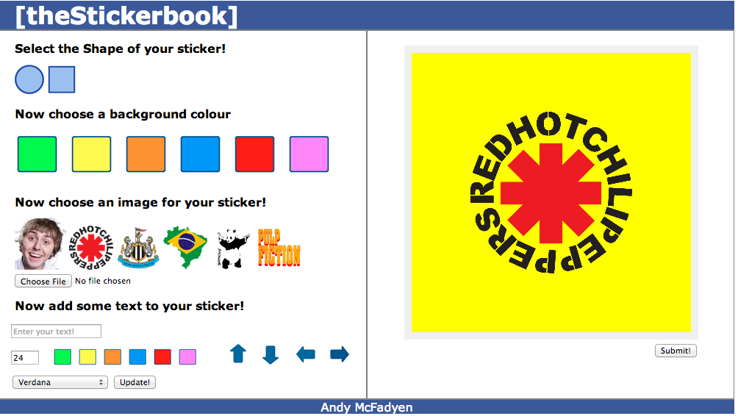

While HTML got all the objects onto the page you would have to style each element individually in order to get it to look the way I wanted. In order to overcome this problem I used CSS. This allowed me to apply styling to groups of elements and could reuse them without setting the same styling attributes to each. One drawback however of CSS is that you may sometimes you may want elements to be styled similarly but not the same. On occasion I found myself still having to use HTML styling due to just a slight alteration. The major advantage I found with CSS was when using multiple pages; I could very quickly create the new page with all the correctly formatted header, footer and page dividers. This allowed me to create the content of the page rather than create things I’ve created before.



One of the most challenging aspects of creating this particular website was that I wanted the different sections of the button to present themselves to the user at different times. I had to control this with JavaScript as it could easily handle user driven event, rather than load when the page loaded. I found this to be a drawback with HTML as it is relatively rigid once the page has been loaded. I started with having just a few elements visible and then when prompted would a call a function that would enable the next group of elements.

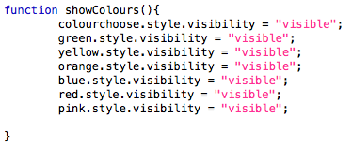

I also used JavaScript to handle adding items to the HTML canvas I found. The constant need to reprint everything on the canvas to change one aspect meant that some of the algorithm for reprinting got quite complex and error prone. This was a particular challenge as there was no easy way to receive error messages from the JavaScript code, it either worked or it didn’t. I found tracking bugs and errors to be very hard while using JavaScript.

I used JavaScript to upload their own images to the canvas. I attempted this using PHP but found the process to be unnecessarily complex.

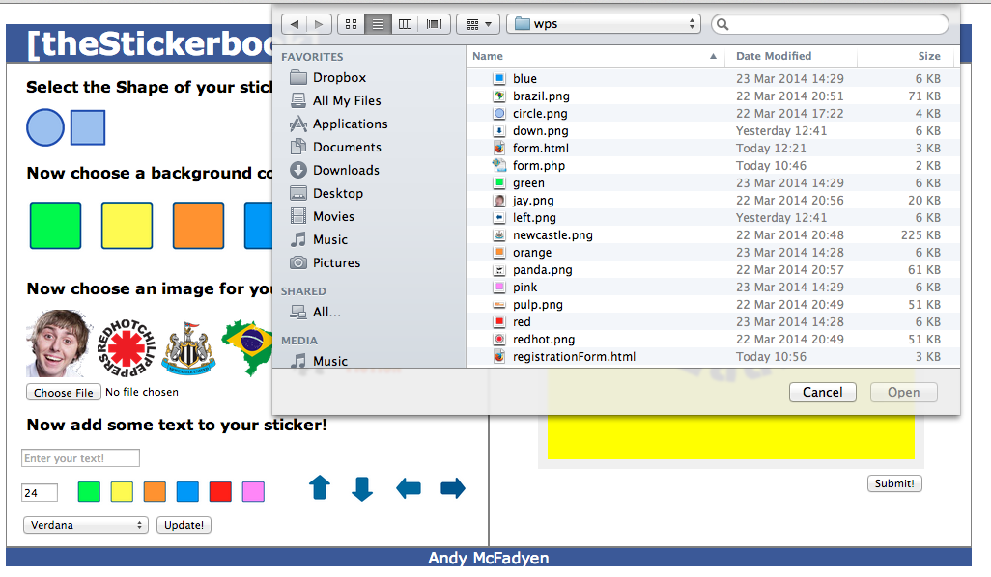

I used PHP to create the booking confirmation page. First the user’s taken to fill in a form, which is created using HTML and CSS.

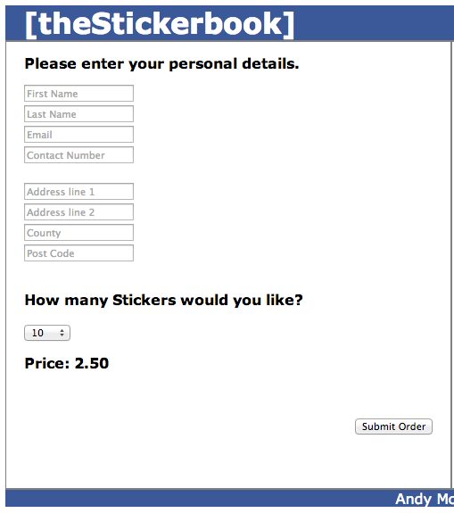

This form gets the users information; quantity of stickers wanted and then calculates the price of the stickers. When the user clicks submit the fields are validated and order form.php is run. This gets all the fields in the form and first prints an order confirmation with the customer name and address. It then saves all the information down to a text file. I found PHP to be very inflexible and difficult to work with. The Syntax is unfamiliar in comparison to a lot of other mainstream language which made it difficult to pick up. It also has virtually no communication with JavaScript due to the fact JavaScript is run in the browser and PHP in the server.

